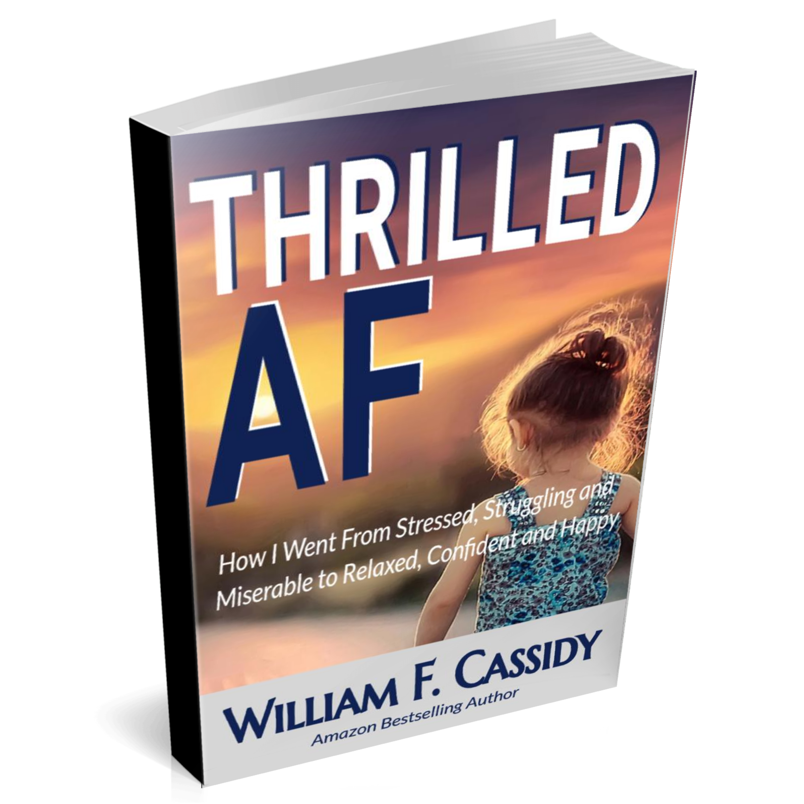

Thrilled AF
How I Went From Stressed, Struggling and Miserable
to Relaxed, Confident and Happy
My Name Is Bill Cassidy and I help people access higher levels of consciousness so they can feel better; and create better.

In this report I quickly share the before, after, highlights and how of my journey to peace, joy and liberation.

The only thing I will say about me before we start is that this has been my lifelong passion. I’ve been meditating for 25 years and studying metaphysics, philosophy and psychology for even longer. And, I’ve done, or still do, everything that I teach.

The details of my spiritual journey are unique, but all spiritual journeys will be similar: a rise of consciousness overcoming the ineffective, inefficient and ugly programming of the mind.

Here’s mine…

How I Went From F’d to Thrilled

My Spiritual Upbringing Before I Started My Journey
I had a pretty good childhood. I was loved, nurtured and nothing happened to me that shouldn’t have happened.

My religious training as a child consisted of Jesus, Cain from Kung Fu and Thoreau. Seriously!

I tried reading The Bible but found much of it impractical. However, I liked reading proverbs.

I remember believing that my spiritual influences knew something that everyone else didn’t and wanting to know what it was.

Maybe John Lennon too. Just saying.

Also, I remember repeating over and over to myself “it’s all about the mind”. “You can’t forget”. “You’re going to forget, but you have to remember it’s all about the mind”. “It’s all about the mind”.

All in all, a good enough childhood to turn me into the normal problem filled adult…

My Spiritual Journey
In 1994 I had had enough and I decided to try something new.

I can say now that this is when my spiritual journey began.

I was in trouble for something. Probably some ticket or fine. Nothing too bad.

Again, something I didn’t want to be happening, was happening? Urgh!

The important part is that this was the first time I realized that what I was saying was then happening in my life.

I realized that I frequently stated ”it’s always something”.

And it was.

So, I stopped saying It’s alway something and started saying something to the effect that life always gets better and better.

My life changed for the better immediately.

But my life still sucked and I knew there had to be something more.

So…

I started taking yoga and Tai Chi classes and I started reading more esoteric books.

It was slow but my life was headed in a better direction.

Eventually I tried meditation, but it wasn’t a consistent tool until years later.

The first spiritual book I read was The Celestine Prophecy.

I remember thinking, as the story unfolded, that life doesn’t work this way.

A guy goes on a spiritual journey and everything magically reveals itself to the guy with perfect timing and precision?

I was like “yea, right”.

But now decades later, I admit I was wrong.

Life does unfold perfectly.

Next, I had the idea from a Joseph Campball book to study a completely different religion.

Because I had some Christian upbringing, I needed to choose something non-abrahamic.

I chose Taoism.

It was absolutely what I was looking for and needed.

Another big step forward…

From that tip I also had my own idea that one religion wasn’t right and all the rest were wrong.

I figured there might logically be themes threaded throughout all religions.

Then, if you looked at all the themes, a pattern would emerge. Main themes.

And, that is what I found.

Eastern religions talk about compassion and acceptance which is very similar to love and forgiveness of Western religions.

When you eliminate what I call nonsensical content, Jesus’s teaching and the Buddha’s are very similar except that they speak from completely different perspectives.

And the clarity and simplicity of Lao Tzu’s wisdom is mind boggling, btw.

Anyhow, there are many similar themes throughout our world’s religions.

They all, however, mostly move in the direction of higher consciousness. Towards whole, connected, stillness, silence and freedom. Away from the worldly attachments, identifications and fears.

The result is a connected, higher vibrational frequency of health, energy, joy and peace.

The next big clue I got was from the time I picked a client’s mind.

He told me that he had been meditating for over 20 years so I asked him what his greatest insight from his practice was.

Without hesitation he told me “The world is as you see it”.

I contemplated this for years as I believed I understood this insight a bit, but certainly not fully.

Little bits of clarity would enter during the next few years but It probably was a decade later before I completely understood this gem of an insight.

And today, I’d still say it’s one of the greatest insights I ever discovered.

And funny enough. I received this at just the right time.

I used it as a guide to see what I hadn’t seen before.

It is one of the most helpful and instructive insights I’ve ever heard shared.

FYI real quick, “the world as you see it” simply means that your reality is not fixed.

It’s a reflection of what you think and believe. So, if you want to change your reality, simply change your mind.

If you change your mind for the better two things will happen: one, your reality will change for the better and two, because you consciously did something, you are growing conscious. That means that your spirit is expanding. And that feels better too.

The next big step in my personal development was when I discovered Osho’s The Book of Secrets.

It’s a serious book about playing with meditations.

Osho is an Indian Guru, aptly known as the spiritually incorrect mystic.

He had such amazing insights into the subtle dynamics of life.

It took me well over 4 years to read and play with all 112 meditations and I still use the book today.

And, I highly recommend it to anyone who is serious about playing with meditations.

If you are new to your journey, I suggest Eckhart Tolle’s Power of Now book.

It’s also an amazing book, but I’d suggest reading it before Secrets.

The Power of Now, however, was what I was reading when I had one of my biggest spiritual growth spurts.

I had $900 in the bank when my truck broke down and of course it was going to cost at least that to fix it.

Also, I’d be without a vehicle for the week and I have no way to get to jobs.

But, immediately I knew not to fight “what is”.

So, I decided that this was an amazing opportunity and was grateful I had some money in the bank.

It ended up being a great week.

I walked and hitchhiked (never had to wait), got really good jobs, met a cute girl and had an amazing week.

I was in the flow and feeling awesome.

Out of my own way and everything coming up Bill.

And pretty much has been since.

BTW, The Book of Secrets is kind of a Tantric book. Tantra is not a religion but a subjective science. That’s a huge clue; take note!

Since then, I’ve been deepening my practice and have discovered so many insights and hacks.

My Spiritual Journey Now
I still play with meditation and I’ve put the best of what I learned on my journey into an actionable, repeatable system.

An efficient and effective system where I’ve tried to eliminate or minimize all the common obstacles.

You see, when I started, I had no idea about my direction other than away from what I had been doing.

If I had a broad overview of the challenge I was actually executing, the mistakes, delays, struggles, confusion, overwhelm and doubt certainly would have been minimized.

That’s the main reason why I created my system.

Your Spiritual Journey
This is quite an extensive topic and very likely, especially if your journey is fresh, much of what I say may not make complete sense.

As you continue forward, you will start to understand everything much clearer.

Here's the broad outline of the plan…

The plan basically has three phases although once you complete the first two, you may have already mastered the third.

Or, you could start from the third as each phase affects the others.

The three phases are Self Realization, Mind Mastery and Conscious Creating.

If you start working on conscious creating, you can’t help but move closer to self realization and mind mastery.

Or, if you master your mind, self realization and better creating is the result.

The process of self realization is the process of your spirit liberating itself from your mind.

This means that your vibrational frequency will rise and you will feel better and better.

When you master your mind, you will feel peace and joy and will eliminate all the ways you previously knew to constrain your spirit and feel “bad”.

Conscious Creating is the carrot of this program and is a natural consequence of self realization and mind mastery.

And, it’s really fun to play with.

Here’s a quick explanation of my system so that you’ll have an idea of how to better help yourself.

Knowing the components makes everything easier.

The Greater Powered System: The Ultimate Fitness System for Your Mind, Body and Spirit

Welcome & Course Overview: This is a quick welcome to the course, course overview and a “how to get the most out of it”.

Phase 1: Self Realization

Know Who You Are: You’ll learn everything you need to know about self realization and getting to know your true, higher, eternal and essential self.

Know What You Want: You can’t get what you want if you don’t know what it is. In this module we make sure that you know what you want and make sure it is aligned with your purpose for being.

Success Positioning: Discover how to put yourself in a better position to succeed and acquire the ability to do everything much more effectively.

Phase 2 Mind Mastery

Improve Your Focus: Learn how to magnify your powers by improving your ability to focus. This is a “must have” skill if you want to be successful – at just about anything.

Remove Detrimental Conscious Beliefs: Discover how to minimize and eliminate the people, circumstances and experiences that you don’t want in your life caused by your negative, unhealthy…beliefs.

Effectuate Beneficial Beliefs: Discover how to invite more of what you want in your life by reinforcing the beliefs that are currently working for you.

Stop Detrimental Thinking: We discuss everything that you need to know to stop thinking thoughts that don’t work for you and make you feel “bad”.

Think Only Beneficial Thoughts: We discuss everything that you need to know to start thinking thoughts that do work for you and make you feel “good”.

Eliminate Detrimental Subconscious Programming: In this module you’ll discover how to eliminate the beliefs that you are not aware of that are sabotaging all your efforts for having a great life.

Leverage Your Subconscious: In this module you’ll learn how to positively program your subconscious to make it work for you so you can minimize your effort and get what you want faster and easier.

Phase 3 Conscious Creating

Consciously Create: This is the module where you’ll learn how to manifest anything you want quickly and easily.

Take Inspired Action: We take a deep dive into accelerating beginner manifestation to help you master conscious creation faster.

Now that you know the path of my and a typical spiritual journey, you should be able to make faster, easier progress.

Yes, you will still have many challenges. And that’s the point. You gain strength as you overcome each challenge.

But, if you want to minimize the unnecessary challenges or you want faster results I’d like to offer you access to me and my system.

If you want faster and easier, click “APPLY” and we’ll talk and see if this path is right for you.

No, hard sell or obligations.

We get on the phone and I try to help you.

If we then agree it’s a good fit, we can move forward.

Like I said, no pressure or obligation.

APPLY

