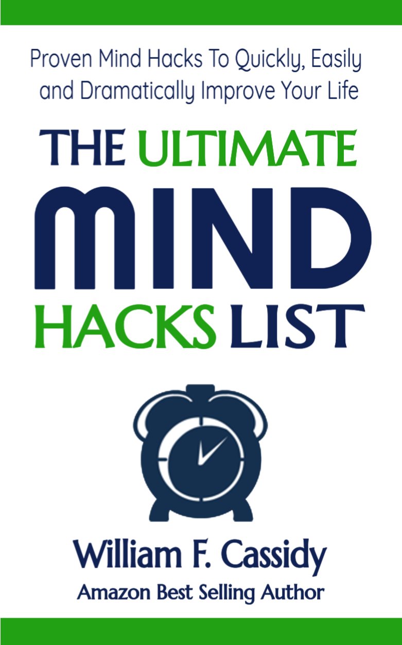

LEGAL

YOUR RIGHTS
This eBook is restricted to your personal use only. It does not come with any other rights.
LEGAL DISCLAIMER
This eBook is protected by international copyright law and may not be copied, reproduced, given away, or used to create derivative works without the publisher’s express permission.
The publisher retains full copyrights to this eBook. The author has made every reasonable effort to be as accurate and complete as possible in the creation of this eBook, and to ensure that the information provided is free from errors. However, the author/publisher/ reseller assumes no responsibility for errors, omissions, or contrary interpretation of the subject matter herein and does not warrant or represent at any time that the contents within are accurate. Any perceived slights of specific persons, peoples, or organizations are unintentional.
The purpose of this eBook is to educate and there are no guarantees of results. The publisher/author/reseller can therefore not be held accountable for any poor results you may attain when implementing the techniques or when following any guidelines set out for you in this eBook.

The Ultimate Mind Hacks List
Mind Hacks To Help You Quickly, Easily
and Dramatically Improve Your Life
Thank you for your interest in this list. I hope that you enjoy it and get some practical benefit from it.

First, let me warn you to be careful about messing with your mind and also to not take anything I say too seriously. You must listen and evaluate what is best for you. If you experience any negative side effects, stop immediately. Let me say that I have safely used each one of these hacks in my own personal practice. That said, messing with your mind can occasionally have unintended consequences (that’s why I always suggest personal coaching.

My name’s Bill and I help people access and leverage higher levels of consciousness for their growth, pleasure and joy.
Mind hacks are simply mental shortcuts to feeling and creating better.

Some listed mind hacks contain subtle similarities and sometimes subtle differences. See if you can spot them.

This is the ultimate mind hacks list (so far)...

- The Ultimate Secret to Life: Consciousness
It took me decades of filtering through teachings by misguided people who didn’t “know” to discover this life altering secret. If you want the ultimate mind hack it’s simply this: Focus on becoming more conscious. Increasing levels of consciousness feel better and better and allow you to create a better physical reality for yourself. Meditation is the best way to increase consciousness.
- The Power of Yes
This is one of the easiest mind hacks to implement. Simply become aware of each time you say “No” and “Yes”. Saying “NO” feeds the ego. Saying “Yes” expands your universe. Start saying “Yes” more frequently. I’m not telling you to be careless or unsafe, but be aware of how often you needlessly say no because of fear or some other excuse. Start saying “yes” and watch all the amazing things that start happening in your life. That’s how easy it is!
- Rate Your State
This is a great mind hack to increase your awareness and become more conscious. And this mind hack is really easy too. Simply, multiple times a day, rate your state. On a scale of one to ten, how great do you feel? Ten being the highest, feeling amazing, healthy, at ease and fulfilled. One being the lowest, feeling like crap, unhealthy, tired, frustrated, and suffering like nothing will ever go your way. That’s it. Rating your state will help you become aware of how you are feeling and anything that can be measured can be improved. This is a great activity to do before and after different activities like meditations and mind hacks but also works for the most mundane activities too. Then, reduce or eliminate whatever activities decrease your state ratings.
- How to Meditate
The simplest, and arguably the best, way to meditate is to get comfortable, relax, straighten your spine, take several deep breaths then breathe naturally. Then, simply observe your thoughts, wait and watch with no judgment. Nothing is to be done. And, every time you find yourself distracted, bring yourself back to watching again. The idea is to consciously stop thinking, or at least increase the gaps between thoughts. That's it.
- Better Self Talk
Unhealthy, unwanted, unnecessary, divisive, limiting, ineffective and disempowering self talk causes low frequency vibrations. Low frequency vibrations attract negative, unhealthy and unwanted people, circumstances and experiences into your life. This drains your energy and propels you downwards towards disease, destruction, decay and death. Overly dramatic, maybe? True, definitely.
- The Easiest Mind Hack Ever: Gratitude
Arguably the easiest mind hack ever. Simply spend as much time as possible each day in gratitude. Do it before or after sleep, eating, activities, circumstances, events and experiences. Do it more for what you are truly most grateful for and you’ll get more of it. Again it starts with being conscious. Then take action and do it.
- Visualization
This is a great mind hack for getting what you want. Simply visualize that which you want with as much detail as possible. Imagination is the key. Besides seeing, use smell, feel, taste, etc. Make it as real as possible. The more “real” it is, the closer to actuality it becomes. Very Simple!
- Better Problems
This is a happy mistake I personally experienced. I thought it would be a good idea to have no problems. I was wrong. You don’t want to have no problems, you want BETTER problems. For example, I want the problem of having to choose again where I’m taking my next vacation.
- Flow State vs. Play
Flow State is a state of being often employed by extreme athletes. Here’s the Wikipedia definition: In positive psychology, a flow state, also known colloquially as being in the zone, is the mental state in which a person performing some activity is fully immersed in a feeling of energized focus, full involvement, and enjoyment in the process of the activity. It seems to me to be extremely similar to play. Read my book The Secret to Happiness to see what I mean.
- How to Never be Lonely
Loneliness is the result of beliefs that you are seperate. You feel lonely because you have thoughts and beliefs that you are separate. Eliminate or change those thoughts and beliefs to you and everything is connected. When you stop thinking and believing that you are separate and that you are connected to everything and everyone, you will never feel lonely again. If your mind just told you that this won't work because it's too simple, we should talk.
- Overcome Anxiety and Depression
The secret to overcoming both anxiety and depression is to be present. When you are in the present moment it is impossible to create anxiety or depression. Anxiety and depression are caused by over-thinking. When present, you are not thinking. Simply be present more often. Meditations are arguably the best techniques for becoming and staying present. Love and gratitude are also great options. However, you'll need to fix your subconscious beliefs to overcome past chronic thinking.
- Watch out for Denying, Escaping, Clinging, Bargaining, Judging
These are all mental activities that are resistant in one way or another. Cultivate acceptance and allowance. Stop the mind from moving.
- Start with Acceptance
The five stages of grief are denial, anger, bargaining, depression and acceptance. So, if you always end at acceptance, why not start there? Denial and bargaining are wasteful and unhealthy mental activities and anger and depression are unhealthy, low frequency emotions. I’ve been doing this for decades so it seems quite easy and it will for you too with a bit of practice. Simply notice when you deny what is, bargain, are angry or depressed, then look for what you are not accepting and accept it. It’s way easier and healthier than you may think. And you’ll have more energy because you’ll stop wasting it.
- I Am the Creator of Everything and 100% Responsible
This is a simple and fun mind hack. Simply pretend or imagine that you are 100% responsible for everything that happens to you in your life. So, if you meet someone new, even if they are horrible, pretend that you attracted them into your life for some reason. Some reason that you may not be aware of or understand, but you did it. Then look for that reason inside and watch what happens.
- Self Realization
Knowing who you are is called Self Realization. Self Realization is the knowing, actualizing and the liberation of your essential, eternal and, often called higher, self and/or soul. Your Essential Self is your "true" self not your ego, mind, past, future and/or body. Your Essential Self is the conscious witness.
- Doubt Is a By-Product of Thinking.
If you are going to doubt anything, doubt your own mind. Doubt is a by-product of thinking. Anytime you think, doubt is created. When in doubt, stop thinking and feel. Try to find the root cause and you’ll see. If you want or need direction, ask the question you want answered and wait and observe, then when you get an answer, how does it make you feel?
- Conscious Creation
Conscious Creation is you applying your knowledge, skills and understanding to consciously decide what you think and believe so that you can create the life of your dreams.
- I Am Worthy, Enough and Capable
Many people are unnecessarily suffering from an army of negative, self defeating thoughts and beliefs that are constantly battling their well being. You need to consciously reprogram your conscious and subconscious thoughts and beliefs to win this war. First understand that you are worthy and enough. You have everything you need and are extremely valuable to us on earth despite what you may currently believe. Read my Blueprint or take my Advanced Training Program.
- The Science of Religion
The original meaning of the word religion is to relink to source. Science and religion both have flaws in helping us to know our source. Religion promotes many teachings that obscure and confuse, and science obstructs and misses what is essential to knowing. You can find out how to relink by researching religious texts, but you could easily spend a lifetime and still miss. Using the principles of modern science you will almost certainly miss. Here’s what you need to know: To relink, you need to become the experiment. You are the experiment. It helps to have a technique to relink. Techniques are also called meditations. Each person has a meditation that suits them best; like a key. When you find the right key/meditation it unlocks you and you relink to source.
- Stop Looking for what is wrong. You Will Find It
Do you ever find yourself looking for what’s wrong? That’s a big clue about your focus. How about trying this instead? Look for what’s healthy, beneficial, enjoyable, fulfilling, prosperous - feels good. The funny thing is that you WILL find whatever you are looking for. Stop looking for the crap and you’ll start finding the gold.
- You Are Not Separate
You are not separate. Nothing in our universe is disconnected or separate. And, the more connected you believe you are the better you’ll feel. Beliefs of separateness makes you feel lonely. If you consciously cultivate your connections, you’ll appreciate life more and your life will generally improve. Meditation is a great way to improve your connection, consciousness and life.
- How Big is Your Hate List?
Many people tell me about what they hate, what they dislike or what’s wrong. It’s like they have a cherished list that they are constantly updating with negative crap to share with others. This activity is usually done unknowingly. This mind hack is easy; stop making and sharing your hate list and start creating and sharing your love list.
- Evil Is NOT a Force
Understand that evil is NOT a force. What we call evil is just the lack of light. Like a shadow. As a shadow is the consequence of blocking the light, evil is the term for unconscious people that act against others. When you are conscious you cannot harm others because you understand that harming others ultimately harms yourself. Also, there is no need, because when you are conscious you have a high vibration and anything you need will manifest for you as you need it. This mind hack will help you move with more compassion towards the light.
- If It Disturbs You, Change Your Mind
Anything that disturbs you is a clue. See it that way. Then look for the cause. Ask yourself why it disturbs you and when was the first time you experienced it. Often the answer is silly and nonsensical. It’s always something you think or believe. Then change it. Or at least stop or minimize your focus on it…
- Choose your Words Carefully
This could be a whole master class by itself. So I’ll just list a few words you should be careful about using due to the fact that they usually are unhealthy and disempowering you. (don’t use I can’t, I have to, I never will, I don’t have, I’m not [something positive], I am [something negative] I need, I want. Use I can, I expect [something positive], I intend, I choose)
- Whatever You Believe Will Be Confirmed with Experiential Evidence
You have thoughts and when you repeat them enough, they become beliefs. When you have beliefs you attract/create evidential experiences that allow you to believe that you are “right”. You become “convinced”. So, say you have repeated thoughts that dogs are dangerous and bite. You begin to believe that dogs are dangerous and bite. Then a dog bites you and you are convinced that dogs are dangerous and bite. But, someone else can have the thought, beliefs and convictions that dogs are friendly and loving. Both of you will be “right”. What I’m saying is you can choose your thoughts, beliefs, convictions and reality. You are the creator, choose wisely!
- Fix the Defective Mental Software
Stop unhealthy, unwanted, unnecessary, divisive, limiting, ineffective and disempowering thoughts, beliefs and activities. Read my Blueprint or take my Advanced Training Program.
- Anytime You Hear Words
You are not in the present moment anytime you think or hear words. This is simply a big clue.
- I Am A Spiritual Being Having a Human Experience
This is a more difficult mind hack due to the fact that it may not arise as often as other hacks. Therefore you will likely forget about it unless it has some major importance in your life. Plus this belief invades and is subtly encompassed into many other beliefs you have. Namely, you identify as a human being. But, however long it takes to cultivate, understand that you are NOT a human being seeking a spiritual experience. You are a spiritual being having a human experience.
- Compliments Not Opposites
Here’s another great mind hack to improve your understanding of the world and ultimately improve your life. Start contemplating everything that you currently see as opposites, look and see how they are two sides of the same coin. Notice the effects of this mind shift on your belief systems and life in general.
- Look For What Feels Good
When you look for what feels good, you will find what feels good. When you find what feels good, appreciate it. When you appreciate and are grateful for what feels good, you’ll attract more of it into your life. If, by chance, you don’t believe you have anything to feel good about. Start with imagination. Imagine how you would feel if you had the good feel in your life. Imagine it fully. Feel it, smell it, taste it. Make it as real as possible. It will then start manifesting into your life. It has to, by law!
- Mind Mastery
Mind mastery is what you do if you want peace, liberation and/or to create the life of your dreams.
- A Unique Expression of Source
The worldly you is a unique expression of the infinite power and intelligence of the universe. You are the source in the same way a wave is the ocean. Not separate, just an expression in form.
- You Are the Master
You have the infinite power and intelligence at your disposal, for your pleasure and growth. Understand this! Believe this, then know this.
- The World Is Perfect
You are where you are supposed to be and the world is perfect. Stop fighting what is. You are making more problems for yourself by fighting it. Your interpretation and perspective is not perfect.
- Congratulate Yourself
This is a simple mind hack anyone can do. Simply congratulate yourself for wins. It starts as most hacks do with being aware. When you notice a win, congratulate yourself and feel “good”. Really FEEL it. That’s key. This can be most beneficial when leveraged to increase something that you want more of in your life. For example, say that you have a new job selling widgets and although you haven’t sold any yet, you made an appointment with a lead. Congratulate yourself for that win and feel good. Now that you feel good, you’ll have a higher vibrational frequency and you will increase your likelihood of making the sale. You can leverage this for anything that you want more of in your life. Read my Blueprint or take my Advanced Training Program.
- Wanting, Wishing And Hoping
These are all examples of scarcity mentality. They are a big reason why, and that which is stopping you from getting what you want.
- Past and Future Thinking are BIG Clues
If you are constantly thinking, you will always be missing the present moment. Learn how to stop your mind. It’s critical to your well being. Meditation means conscious non thinking. It’s never too late or too early to start.
- How to Eliminate Guilt
Guilt is feeling bad about the same thing over and over again. Feel bad only once. Use it as a clue to learn and grow. Then accept and move on. Conscious mind mastery is the skill you need.
- It's Your Choice: Friend, Lover or an Enemy
Did you know it’s your choice? If someone hurts you, it’s likely more about them than you anyway. But if you decide that you will be their friend and love them despite their actions, it’s to your benefit. And theirs too. Make no mistake, it’s a choice. You are likely not consciously choosing. Ask yourself, if it’s conscious or emotional.
- Be Loving
Love is a state of mind not a relationship. Simply be loving towards everything and everyone. It is not as difficult as you may think. Just notice, then drop the hate, anger and resistance. Forgive, accept, then be loving. It’s a choice. Being loving benefits you and being hateful is detrimental to your well being. Simply practice more and more. Use imagination if you want. By and by the quality of your state of mind will improve as well as everything else in your life.
- Worrying Increases That Which You Don't Want
Worrying is like negative goal setting. It doesn’t help and it increases the chance of creating what you don’t want. Instead of worrying, imagine the outcome that you do want. Imagine how you would feel with the outcome that you do want. Imagine it fully. Feel it, smell it, taste it. Make it as real as possible. This will increase the possibility of you getting the outcome that you do want.
- Stop Agreeing with Stupid Shit
I love this one. It’s simple. Simply start paying attention to the things people say, the news you read, etc. Think about it a second to see if it makes sense and that you really agree. You will begin to see that it’s easy to agree with stuff that doesn’t make sense when you are not paying attention. You’ll also discover how much stupid shit people say. One of my favorites that people often unconsciously repeat is "you only live once". Well how do you know and what about the thousands of enlightened people who have told us differently?
- You Have Permission to Express Yourself
Be yourself and express yourself. You have my permission (but who cares). Now, give yourself permission to be authentically you - fully, completely and uniquely.
- The Secret to Happiness
Cultivate an attitude of playfulness. Read my book The Secret to Happiness to see what I mean. It’s FREE.
- Who's to Blame?
Blaming is simply a waste of your time and energy. See Mind Hack “I Am the Creator of Everything and 100% Responsible”.
- Surrender
This will save a lot of your energy. There is something magical that happens when you surrender. You become more real and less mind and ego. The object doesn’t matter. Also, surrender doesn’t mean not caring.
- Learn the Skill of Enjoying What You Have
When you enjoy what you have you’ll stop creating that which you don’t want and will start creating more of what you truly enjoy and want more of in your life.
- Why I Like Everything
First, it forces you to be aware, second, your focus is beneficial. It will often be in love and gratitude. Third, your focus will not be on that which is detrimental. Fourth, you’ll start creating more of what you truly enjoy and want more of in your life.
- Let Go of Outcomes
Stop wasting your energy on outcomes. You are not present and are missing the present moment. And, if you are present, there will be no reason to worry about outcomes. Everything will take care of itself exactly as it should. And, it will work out more frequently for your benefit and pleasure.
BONUS: For getting and reading this list I want to give you the mind hack that permanently solves your biggest problem, for free: https://wfcassidy.com/fmh

Feel and create your best when you get the Ultimate Fitness System for your mind, body and soul at: GreaterPowered.com. Additional training and support can be found at: WFCassidy.com.

